**RIPHAH INTERNATIONAL UNIVERSITY**



**Name: SALEHA RAFIQUE**

**SAP ID: 49316**

**Operating System Lab**

**SUBMITTED TO: MA’AM AYESHA AKRAM**

**Creating:**

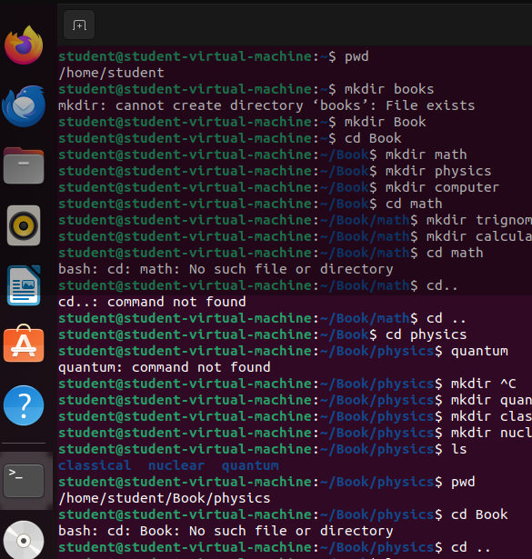

**TASK 01:**

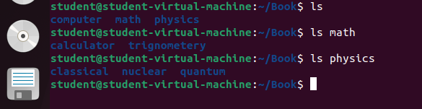

**Creating Chemistry and going to home**

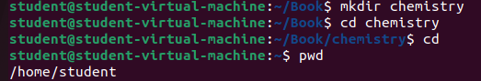

**Task 02:**

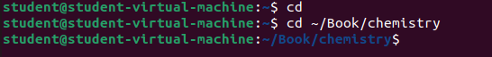

It’s a relative Path. Because we move directly from home directory to chemistry directory.

**Task 03:**

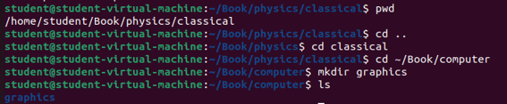

**Task 04**

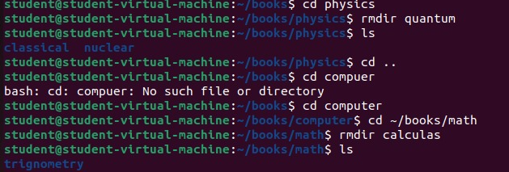

**TASK 05:**

1. pwd: Print Working Directory. Displays the current working directory.

2. ls: List. Displays a list of files and directories in the current directory.

Example: ls (lists the files and directories in the current directory)

3. ls -l: List in long format. Displays detailed information about files and directories.

4. ls –r: Reverse the order.

5.ls –a: show all files also hidden files

6. cd: Change Directory. Used to navigate to a different directory.

7. cd : Takes you to your home directory.

8. cd ..: Moves to the parent directory (one level up).

9. cd /: Takes you to the root directory.\

Directory Management Commands

10. mkdir: Make Directory. Creates a new directory.

11. rmdir: Remove Directory. Deletes an empty directory.

12. rm -r: Remove Directory and its contents. Deletes a directory and all its contents.

13. ls: List. Displays a list of files and directories in the current directory.

Example: ls (lists the files and directories in the current directory)

14. ls -l: List in long format. Displays detailed information about files and directories.

15. ls –r: Reverse the order.

16.ls –a: show all files also hidden files